Dokumentacija

https://nikolinanikolic90.github.io/restauco/index.html

Predmet : Web programiranje 1 Nikolina Nikolić 90/19

Decembar 2021.

Sadržaj

Uvod 3

Korišćeni programski jezici i tehnologije 3

Opis funkcionalnosti 3

Template 3

Organizacija 4

Organizaciona šema 4

Mapa sajta 4

Stranice 5

Home 5

Menu 6

About 7

Reservation 8

Kodovi 9

HTML 9

Index.html 9

Menu.html 12

Events.html **Error! Bookmark not defined.**

About.html 14

Reservation.html 16

CSS 19

Style.css **Error! Bookmark not defined.**

JavaScript 28

Main.js **Error! Bookmark not defined.**

# Uvod

## Korišćeni programski jezici i tehnologije

HTML, CSS, Bootstrap, JavaScript, Jquery, Slick Carousel Plugin

## Opis funkcionalnosti

* Responsive sajt, samostalno pisan kod
* ‘Sendvič’ dugme za otvaranje navigacije na manjim uređajima
* Dinamičko ispisivanje navigacije na svim stranama
* Dinamičko ispisivanje galerije na početnoj strani
* Dinamičko ispisivanje događaja na events strani
* Dinamičko ispisivanje mušterija(Slick Carousel) na početnoj strani
* Dinamičko popunjavanje dropdown liste na reservation strani
* Validacija forme na reservation strani
* Dinamičko ispisivanje footer-a na svim stranama
* Slajder na about strani
* Filtriranje jela na menu strani
* ‘Back to top’ stelica
* Show more text na about strani
* Modal za prikazivanje podataka o autoru na svim stranama

## Template

Nije korišćen template, kod je samostalno pisan, ideja je preuzeta sa komercijalnih sajtova i template-a.

# Organizacija

## Organizaciona šema

Svakoj stranici je moguće pristupiti sa svih stranica.

## Mapa sajta

<urlset xmlns="http://www.sitemaps.org/schemas/sitemap/0.9">

<url>

<loc>https://nikolinanikolic90.github.io/restauco/index.html</loc>

<lastmod>2019-06-12</lastmod>

<changefreq>weekly</changefreq>

<priority>1</priority>

</url>

<url>

<loc>https://nikolinanikolic90.github.io/restauco/menu.html</loc>

<lastmod>2019-06-12</lastmod>

<changefreq>monthly</changefreq>

<priority>0.9</priority>

</url>

<url>

<loc>https://nikolinanikolic90.github.io/restauco/reservation.html</loc>

<lastmod>2019-06-12</lastmod>

<changefreq>yearly</changefreq>

<priority>0.8</priority>

</url>

<url>

<loc>https://nikolinanikolic90.github.io/restauco/about.html</loc>

<lastmod>2019-06-12</lastmod>

<changefreq>yearly</changefreq>

<priority>0.8</priority>

</url>

</urlset>

## Stranice

### Home

Na ovoj stranici prikazani su dinamički header I footer, dinamički ispis događaja, dinamički ispis mušterija(slick carousel plugin), dinamički ispis galerije I scroll to top link.

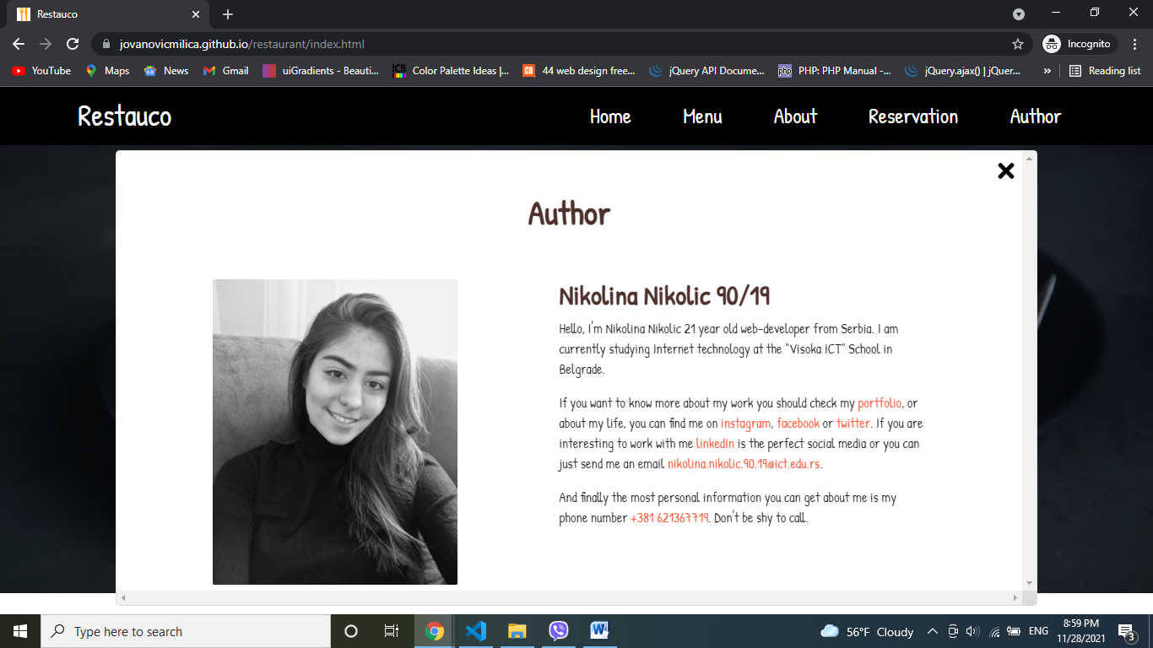

Na ovoj slici prikazan je modal sa tekstom o autoru. Moguće je ga otvoriti sa svih strana. Kada se otvori, ostatak sajta se ne može skrolovati.

### Menu

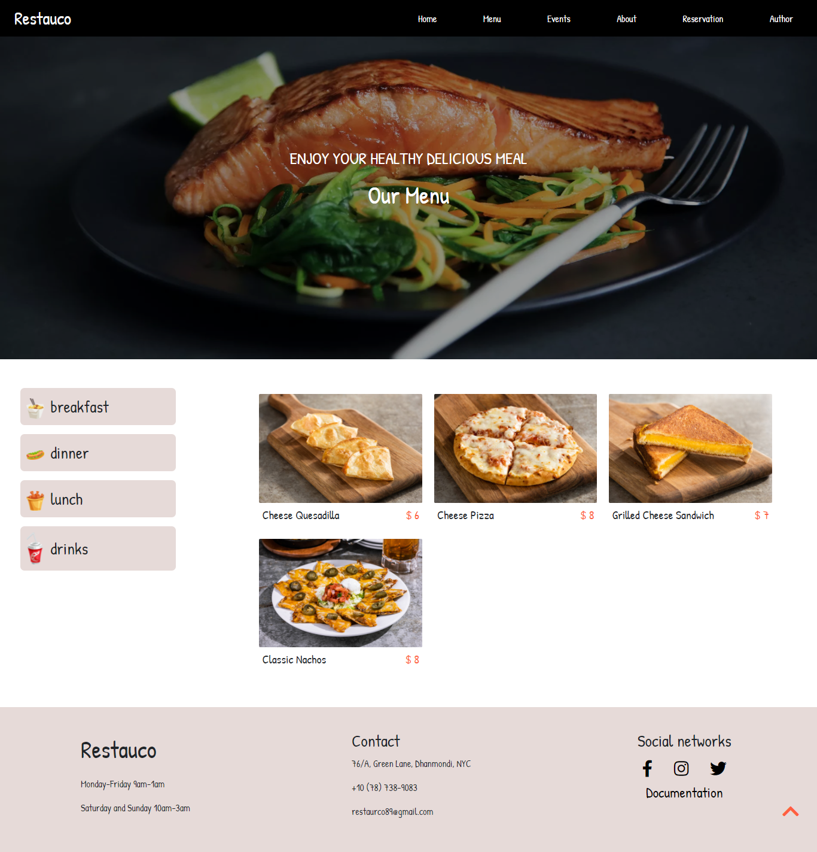

Na ovoj stranici prikazani su dinamički header ,footer, scroll to top link. Dinamički ispis kategorija jela I jela. Klikom na neku od kategorija, ispisuju se samo njena jela

### About

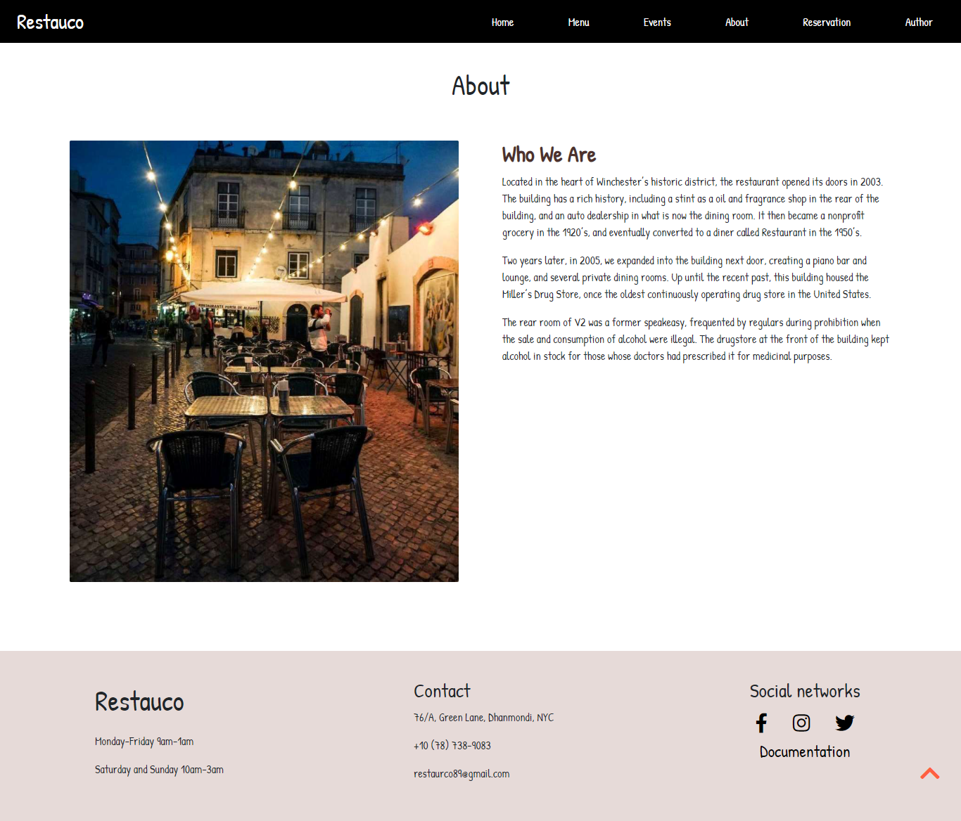

Na ovoj stranici prikazani su dinamički header, footer, scroll to top link I slajder koji menja sliku na 2s. Klikom na link “show more” pojavljuje se ostatak teksta

### Reservation

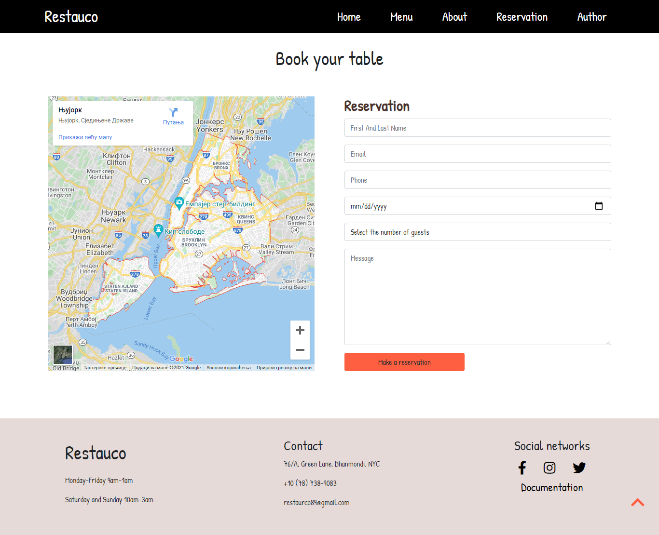

Na ovoj stranici prikazani su dinamički header,footer, scroll to top link i forma. Izlaskom iz polja vrši se validacija i prilikom klika na dugme. Ispisuju se odgovarajuće poruke.

# Kodovi

## HTML

### Index.html

<!DOCTYPE html>

<html lang="en">

<head>

    <meta charset="UTF-8">

    <meta http-equiv="X-UA-Compatible" content="IE=edge">

    <meta name="viewport" content="width=device-width, initial-scale=1.0"><link rel="preconnect" href="https://fonts.googleapis.com">

    <link rel="preconnect" href="https://fonts.gstatic.com" crossorigin>

    <link href="https://fonts.googleapis.com/css2?family=Patrick+Hand&display=swap" rel="stylesheet">

    <link href="https://cdn.jsdelivr.net/npm/bootstrap@5.1.3/dist/css/bootstrap.min.css" rel="stylesheet" integrity="sha384-1BmE4kWBq78iYhFldvKuhfTAU6auU8tT94WrHftjDbrCEXSU1oBoqyl2QvZ6jIW3" crossorigin="anonymous">

    <!-- Plugin -->

    <link rel="stylesheet" type="text/css" href="https://cdnjs.cloudflare.com/ajax/libs/slick-carousel/1.8.1/slick-theme.min.css"/>

    <link rel="stylesheet" type="text/css" href="https://cdnjs.cloudflare.com/ajax/libs/slick-carousel/1.8.1/slick.min.css"/>

    <!-- End Plugin -->

    <link rel="stylesheet" href="https://cdnjs.cloudflare.com/ajax/libs/font-awesome/5.15.1/css/all.min.css">

    <link rel="stylesheet" href="assets/css/style.css">

    <title>Restauco</title>

    <link rel="shortcut icon" href="assets/images/logo.ico" type="image/x-icon">

    <meta name="author" content="Nikolina Nikolic">

    <meta name="description" content="Located in the heart of Winchester’s historic district, the restaurant opened its doors in 2003."/>

    <meta name="keywords" content="Restauco, Restaurant, Fast Food, Healthy Food, Delicious Coffee"/>

</head>

<body>

    <div class="headerWrapper">

        <header class="py-2 px-4 d-flex align-items-center justify-content-between">

                <div id="logo">

                    <a href="index.html" class="text-decoration-none text-light">

                        Restauco

                    </a>

                </div>

                <nav id="nav"></nav>

        </header>

    </div>

    <div class="headerImage">

        <div class="cover">

            <div class="heading">

                <p class="fs-3">ENJOY YOUR HEALTHY DELICIOUS MEAL</p>

                <h1 class="fs-1">Treat Yourself</h1>

            </div>

        </div>

    </div>

    <main class="my-5">

        <div class="heading py-5">

            <h1 class="fs-1">Events</h1>

        </div>

        <div id="events">

        </div>

        <div id="offer" class="my-5 d-flex flex-wrap align-items-center justify-content-between">

        </div>

        <div class="heading my-5">

            <h2 class="my-3">What our customer sayes</h2>

        </div>

        <div id="customers" class="container-fluid my-5">

            <div class="row">

                <div class="col-10 customersSlider mx-auto"></div>

            </div>

        </div>

        <div id="book">

            <div>

                <h3>Book a table now</h3>

                <p>For Ant Booking Queries Call Us On +10 (78) 738-9083.</p>

                <a href="reservation.html" class="text-decoration-none btn">Book now</a>

            </div>

        </div>

        <div class="heading my-5">

            <h2 class="my-3">Gallery</h2>

        </div>

        <div id="gallery" class="d-flex flex-wrap">

        </div>

    </main>

    <div id="backToTop" class="d-none">

        <a href="#"><i class="fas fa-chevron-up fs-2"></i></a>

    </div>

    <div id="backToTop" class="d-none">

        <a href="#"><i class="fas fa-chevron-up fs-2"></i></a>

    </div>

    <footer></footer>

    <div id="modal" class="d-none">

    </div>

    <script src="https://ajax.googleapis.com/ajax/libs/jquery/3.5.1/jquery.min.js"></script>

    <!-- Plugin -->

    <script type="text/javascript" src="https://cdnjs.cloudflare.com/ajax/libs/slick-carousel/1.8.1/slick.min.js"></script>

    <!-- End Plugin -->

    <script src="assets/js/main.js" type="text/javascript"></script>

</body>

</html>

### Menu.html

<!DOCTYPE html>

<html lang="en">

<head>

    <meta charset="UTF-8">

    <meta http-equiv="X-UA-Compatible" content="IE=edge">

    <meta name="viewport" content="width=device-width, initial-scale=1.0"><link rel="preconnect" href="https://fonts.googleapis.com">

    <link rel="preconnect" href="https://fonts.gstatic.com" crossorigin>

    <link href="https://fonts.googleapis.com/css2?family=Patrick+Hand&display=swap" rel="stylesheet">

    <link href="https://cdn.jsdelivr.net/npm/bootstrap@5.1.3/dist/css/bootstrap.min.css" rel="stylesheet" integrity="sha384-1BmE4kWBq78iYhFldvKuhfTAU6auU8tT94WrHftjDbrCEXSU1oBoqyl2QvZ6jIW3" crossorigin="anonymous">

    <link rel="stylesheet" href="https://cdnjs.cloudflare.com/ajax/libs/font-awesome/5.15.1/css/all.min.css">

    <link rel="stylesheet" href="assets/css/style.css">

    <title>Restauco</title>

    <link rel="shortcut icon" href="assets/images/logo.ico" type="image/x-icon">

    <meta name="author" content="Nikolina Nikolic">

    <meta name="description" content="Do yourself a favor and visit this lovely restaurant . Work hard, be nice, eat pasta. It's about more than just a dining room away from home. Menu is extensive and seasonal to a particularly high standard."/>

    <meta name="keywords" content="Restaurant, Drinks, Lunch, Breakfast, Dinner"/>

</head>

<body>

    <header class="py-2 px-4 d-flex align-items-center justify-content-between">

        <div id="logo">

            <a href="index.html" class="text-decoration-none text-light">

                Restauco

            </a>

        </div>

        <nav id="nav"></nav>

    </header>

    <div class="headerImage">

        <div class="cover">

            <div class="heading">

                <p class="fs-3">ENJOY YOUR HEALTHY DELICIOUS MEAL</p>

                <h1 class="fs-1">Our Menu</h1>

            </div>

        </div>

    </div>

    <main class="my-5">

        <div class="mealWrapper">

            <div id="mealTypes">

            </div>

            <div id="meals">

            </div>

        </div>

    </main>

    <div id="backToTop" class="d-none">

        <a href="#"><i class="fas fa-chevron-up fs-2"></i></a>

    </div>

    <footer></footer>

<div id="modal" class="d-none">

    </div>

    <script src="https://ajax.googleapis.com/ajax/libs/jquery/3.5.1/jquery.min.js"></script>

    <script src="assets/js/main.js" type="text/javascript"></script>

</body>

</html>

### About.html

<!DOCTYPE html>

<html lang="en">

<head>

    <meta charset="UTF-8">

    <meta http-equiv="X-UA-Compatible" content="IE=edge">

    <meta name="viewport" content="width=device-width, initial-scale=1.0"><link rel="preconnect" href="https://fonts.googleapis.com">

    <link rel="preconnect" href="https://fonts.gstatic.com" crossorigin>

    <link href="https://fonts.googleapis.com/css2?family=Patrick+Hand&display=swap" rel="stylesheet">

    <link href="https://cdn.jsdelivr.net/npm/bootstrap@5.1.3/dist/css/bootstrap.min.css" rel="stylesheet" integrity="sha384-1BmE4kWBq78iYhFldvKuhfTAU6auU8tT94WrHftjDbrCEXSU1oBoqyl2QvZ6jIW3" crossorigin="anonymous">

    <link rel="stylesheet" href="https://cdnjs.cloudflare.com/ajax/libs/font-awesome/5.15.1/css/all.min.css">

    <link rel="stylesheet" href="assets/css/style.css">

    <title>Restauco</title>

    <link rel="shortcut icon" href="assets/images/logo.ico" type="image/x-icon">

    <meta name="author" content="Nikolina Nikolic">

    <meta name="description" content="Don’t listen to people who tell you you can’t eat a whole pizza, you don’t need that kind of negativity in your life. Located in the heart of Winchester’s historic district, the restaurant opened its doors in 2003."/>

    <meta name="keywords" content="Restaurant, About us, Restauco,Green Lane Dhanmondi NYC"/>

</head>

<body>

    <header class="py-2 px-4 d-flex align-items-center justify-content-between">

        <div id="logo">

            <a href="index.html" class="text-decoration-none text-light">

                Restauco

            </a>

        </div>

        <nav id="nav"></nav>

    </header>

    <main class="py-5">

        <div class="heading py-5">

            <h1 class="fs-1">About</h1>

        </div>

        <div class="ImageWithText">

            <div>

                <img id="slider" src="" alt="Restaurant image" class="img-fluid">

            </div>

            <div>

                <h2>Who We Are</h2>

                <p>Located in the heart of Winchester’s historic district, the restaurant opened its doors in 2003. The building has a rich history, including a stint as a oil and fragrance shop in the rear of the building, and an auto dealership in what is now the dining room. It then became a nonprofit grocery in the 1920’s, and eventually converted to a diner called Restaurant in the 1950’s.</p>

<a href="#" id="more">Show more</a>

                <p class="d-none">Two years later, in 2005, we expanded into the building next door, creating a piano bar and lounge, and several private dining rooms. Up until the recent past, this building housed the Miller’s Drug Store, once the oldest continuously operating drug store in the United States.</p>

                <p class="d-none">The rear room of V2 was a former speakeasy, frequented by regulars during prohibition when the sale and consumption of alcohol were illegal. The drugstore at the front of the building kept alcohol in stock for those whose doctors had prescribed it for medicinal purposes.</p>

            </div>

        </div>

    </main>

    <div id="backToTop" class="d-none">

        <a href="#"><i class="fas fa-chevron-up fs-2"></i></a>

    </div>

    <footer></footer>

    <div id="modal" class="d-none">

    </div>

    <script src="https://ajax.googleapis.com/ajax/libs/jquery/3.5.1/jquery.min.js"></script>

    <script src="assets/js/main.js" type="text/javascript"></script>

</body>

</html>

### Reservation.html

<!DOCTYPE html>

<html lang="en">

<head>

    <meta charset="UTF-8">

    <meta http-equiv="X-UA-Compatible" content="IE=edge">

    <meta name="viewport" content="width=device-width, initial-scale=1.0"><link rel="preconnect" href="https://fonts.googleapis.com">

    <link rel="preconnect" href="https://fonts.gstatic.com" crossorigin>

    <link href="https://fonts.googleapis.com/css2?family=Patrick+Hand&display=swap" rel="stylesheet">

    <link href="https://cdn.jsdelivr.net/npm/bootstrap@5.1.3/dist/css/bootstrap.min.css" rel="stylesheet" integrity="sha384-1BmE4kWBq78iYhFldvKuhfTAU6auU8tT94WrHftjDbrCEXSU1oBoqyl2QvZ6jIW3" crossorigin="anonymous">

    <link rel="stylesheet" href="https://cdnjs.cloudflare.com/ajax/libs/font-awesome/5.15.1/css/all.min.css">

    <link rel="stylesheet" href="assets/css/style.css">

    <title>Restauco</title>

    <link rel="shortcut icon" href="assets/images/logo.ico" type="image/x-icon">

    <meta name="author" content="Nikolina Nikolic">

    <meta name="description" content="Do yourself a favor and visit this lovely restaurant . Work hard, be nice, eat pasta. It's about more than just a dining room away from home. Menu is extensive and seasonal to a particularly high standard."/>

    <meta name="keywords" content="Restauco, Restaurant, Reservation, Book Now, Best Restaurant"/>

</head>

<body>

    <div class="headerWrapper">

    <header class="py-2 px-4 d-flex align-items-center justify-content-between">

        <div id="logo">

            <a href="index.html" class="text-decoration-none text-light">

                Restauco

            </a>

        </div>

        <nav id="nav"></nav>

    </header>

    </div>

    <main class="py-5">

        <div class="heading py-5">

            <h1 class="fs-1">Book your table</h1>

        </div>

        <div class="ImageWithText">

            <div><iframe src="https://www.google.com/maps/embed?pb=!1m18!1m12!1m3!1d387190.2799160891!2d-74.25987584510595!3d40.69767006338158!2m3!1f0!2f0!3f0!3m2!1i1024!2i768!4f13.1!3m3!1m2!1s0x89c24fa5d33f083b%3A0xc80b8f06e177fe62!2z0IrRg9GY0L7RgNC6LCDQodGY0LXQtNC40ZrQtdC90LUg0JTRgNC20LDQstC1!5e0!3m2!1ssr!2srs!4v1637850892252!5m2!1ssr!2srs" style="border:0;" allowfullscreen="" loading="lazy"></iframe>

            </div>

            <div>

                <h2>Reservation</h2>

                <div id="form">

                    <form action="#" method="#">

                        <div class="input-group mb-3">

                            <input id="name" type="text" class="form-control" placeholder="First And Last Name">

                        </div>

                        <p class="text-danger d-none">Correct format eg. Nikolic Nikolina</p>

                        <div class="input-group mb-3">

                            <input id="email" type="text" class="form-control" placeholder="Email" >

                        </div>

                        <p class="text-danger d-none">Correct format eg. nikolina@gmail.com</p>

                        <div class="input-group mb-3">

                            <input id="phone" type="text" class="form-control" placeholder="Phone" >

                        </div>

                        <p class="text-danger d-none">Phone eg.066123456 or 0621234567</p>

                        <div class="input-group mb-3">

                            <input class="form-control" type="date" name="date" id="date">

                        </div>

                        <p class="text-danger d-none">Choose day in future</p>

                        <div class="input-group mb-3">

                            <select name="guests" id="ddGuests" class="form-control">

                                <option value="0">Select the number of guests</option>

                            </select>

                        </div>

                        <p class="text-danger d-none">You have to choose guests number</p>

                        <div class="input-group">

                            <textarea id="message" placeholder="Message" class="form-control" aria-label="With textarea"></textarea>

                        </div>

                        <p class="text-danger d-none">Message has 5 words minimum</p>

                        <div class="btn-group mt-3">

                            <button type="button" id="buttonMessage" class="btn text-dark">Make a reservation</button>

                        </div>

                        <p class="text-success d-none mt-2">Thanks for your reservation!</p>

                    </form>

                </div>

            </div>

        </div>

    </main>

    <div id="backToTop" class="d-none">

        <a href="#"><i class="fas fa-chevron-up fs-2"></i></a>

    </div>

    <footer></footer>

    <div id="modal" class="d-none">

    </div>

    <script src="https://ajax.googleapis.com/ajax/libs/jquery/3.5.1/jquery.min.js"></script>

    <script src="assets/js/main.js" type="text/javascript"></script>

</body>

</html>

## CSS

### Style.css

*{

    margin: 0px;

    padding: 0px;

    box-sizing: border-box;

}

body{

    font-family: 'Patrick Hand', cursive;

}

.headerWrapper{

    width: 100%;

    position: fixed;

    z-index: 99;

    background-color: #000;

}

header{

    width: 90%;

    margin: 0px auto;

}

header nav{

    width: 50%;

}

.headerImage{

    width: 100%;

    height: 600px;

    background-image: url("../images/mainPhoto.webp");

    background-repeat: no-repeat;

    background-size: cover;

    background-position: center;

    background-attachment: fixed;

}

.cover{

    position: relative;

    width: 100%;

    color: #fff;

    height: 100%;

    background-color: rgba(0, 0, 0, 0.397);

    display: flex;

    flex-direction: column;

    justify-content: center;

}

.heading{

    width: 70%;

    margin: 0px auto;

    text-align: center;

}

h2{

    color: #4d312c;

    font-weight: bold;

}

#offer,#gallery,#events{

    width: 95%;

    margin: 0px auto;

}

.oneOffer{

    width: 30%;

    border: 1px solid #e6dad8;

    padding: 30px;

    border-radius: 7px;

}

.oneOffer:hover{

    border: 1px solid #fff;

    box-shadow: 0 20px 30px rgb(254 95 65 / 10%);

}

.oneOffer h3:hover{

    color: #fe5f41;

}

.oneOffer h3, .oneOffer p{

    margin: 25px 0px;

}

.customer{

    border: 1px solid #fe5f41;

    padding: 30px;

    border-radius: 7px;

    margin: 0px 10px;

    text-align: center;

}

.customer div{

    width: 75%;

    margin: 0px auto;

}

img{

    border-radius: 2px;

}

.customer img{

    border-radius: 50%;

}

.customer p{

    margin: 10px;

}

.slick-prev:before,.slick-next:before{

    color: #fe5f41;

}

ul li{

    list-style-type: none;

}

nav ul{

    display: flex;

    align-items: center;

    justify-content: space-between;

}

#book{

    width: 100%;

    text-align: center;

    background-image: url("../images/book.webp");

    background-repeat: no-repeat;

    background-size: cover;

    background-attachment: fixed;

}

#book div{

    padding: 80px;

    background-color: #f5c97ee6;

}

.meal{

    width: 25%;

}

.meal img:hover{

    transform: scale(1.1);

    transition: ease;

    transition-duration: 0.2s;

}

footer{

    margin-top: 50px;

    width: 100%;

    background-color: #e6dad8;

    display: flex;

    justify-content: space-around;

    text-align: justify;

    flex-wrap: wrap;

    padding: 40px 0px;

}

.mreze{

    text-align: center;

}

.mealWrapper{

    width: 95%;

    margin: 0px auto;

    display: flex;

    flex-wrap: wrap;

    justify-content: space-between;

}

#mealTypes{

    width: 20%;

}

#meals{

    width: 70%;

    display: flex;

    flex-wrap: wrap;

    justify-content: flex-start;

}

.mealTypeImage img{

    width: 30px;

    margin-right: 10px;

}

#mealTypes ul li a{

    display: flex;

    align-items: center;

    padding: 10px;

}

#mealTypes ul li{

    background-color: #e6dad8;

    border-radius: 7px;

    margin-bottom: 15px;

}

.oneMeal{

    width: 30%;

    margin: 10px 10px;

    display: flex;

    flex-wrap: wrap;

    justify-content: space-between;

}

.price{

    color: #fe5f41;

}

.oneMeal p{

    margin: 5px;

    font-size: 20px;

}

#mealTypes ul .active{

    background-color: #bcb6b5;

}

#events{

    display: flex;

    flex-wrap: wrap;

    justify-content: center;

}

.event{

    width: 90%;

    margin: 0px auto;

    display: flex;

    flex-wrap: wrap;

    justify-content: space-between;

    margin: 15px 0px;

}

.event:nth-child(even){

    flex-direction: row-reverse;

}

.event div{

    width: 45%;

}

.ImageWithText{

    width: 90%;

    margin: 0px auto;

    display: flex;

    justify-content: space-around;

    flex-wrap: wrap;

}

.ImageWithText div{

    width: 45%;

}

.ImageWithText #form,.ImageWithText #form .input-group{

    width: 100%;

}

#message{

    height: 200px;

}

iframe{

    width: 100%;

    height: 100%;

}

.btn{

    background-color: #fe5f41;

}

/* .form-control:focus,.btn:focus{

    border-color: #fe5f41;

    box-shadow: 0 0 0 0.25rem #fe5f4142

} */

#backToTop{

    position: fixed;

    z-index: 99;

    bottom: 50px;

    right: 30px;

}

#backToTop a{

    color: #fe5f41;

}

#mobileNav{

    display: none;

}

#mobileNav ul{

    display: none;

}

#navSmall{

    position: absolute;

    top: 61px;

    background-color: rgb(0, 0, 0);

    padding: 10px 20px;

    left: 0px;

    right: 0px;

    text-align: center;

}

#navSmall li{

    margin: 15px 0px;

}

#navSmall li a{

    padding: 10px;

}

#logo a{

    font-size: 35px;

}

.ImageWithText a{

    text-decoration: none;

    color: #fe5f41;

}

header ul li a{

    color: #fff;

    font-size: 25px;

}

footer a{

    color: #000;

}

header ul li a:hover,footer a:hover{

    color: #fe5f41;

}

.ImageWithText .authorImage{

    width: 30%;

}

#modal{

    position: fixed;

    left: 10%;

    right: 10%;

    top: 75px;

    bottom: 10px;

    z-index: 99;

    background-color: #fff;

    border: 1px solid rgb(221, 221, 221);

    border-radius: 5px;

}

.scroll{

    overflow: hidden;

}

#close{

    position: absolute;

    right: 10px;

    top: 10px;

    color: #000;

}

#modal{

    overflow: scroll;

}

@media screen and (max-width:768px){

    #mealTypes,#meals{

        width: 100%;

    }

    #mealTypes ul{

        display: flex;

        justify-content: space-between;

        align-items: center;

        flex-wrap: wrap;

    }

    .mealTypeImage img{

        height: 30px;

        width: auto;

    }

    #mealTypes ul li{

        margin: 5px;

    }

    #events,.ImageWithText{

        justify-content: center;

    }

    .event div{

        width: 100%;

    }

    .ImageWithText div{

        margin: 10px 0px;

        width: 100%;

    }

    #navLarge{

        display: none;

    }

    #mobileNav{

        display: block;

        text-align: right;

    }

    footer{

        justify-content: center;

    }

    footer .blok{

        text-align: center;

        width: 100%;

        margin: 10px 0px;

    }

}

@media screen and (max-width:586px){

    #offer{

        justify-content: center!important;

    }

    .oneOffer{

        width: 90%;

    }

    .meal{

        width: 50%;

    }

    #gallery{

        width: 100%;

    }

    .meal img:hover{

        transform: scale(1);

    }

    #mealTypes ul{

        justify-content: center;

    }

    .oneMeal{

        width: 100%;

    }

}

## JavaScript

### Main.js

$(document).ready(function(){

    getNavigation()

    getFooter()

})

$(window).scroll(function(e){

    e.preventDefault()

    if(window.pageYOffset>100){

        $("#backToTop").removeClass("d-none")

    }

    else{

        $("#backToTop").addClass("d-none")

    }

})

var navName=['Home','Menu','About','Reservation','Author']

var navLink=['index.html','menu.html','about.html','reservation.html','#']

function getNavigation(){

    var ispis='<ul id="navLarge" class="m-0 px-3">'

    for(let i=0;i<navName.length;i++){

        ispis+=`<li><a id="${navName[i]}" class="text-decoration-none" href="${navLink[i]}">${navName[i]}</a></li>`

    }

    ispis+="</ul>"

    ispis+=`<div id="mobileNav">`

        ispis+=`<a href="#"><i class="text-light fs-3 fa fa-bars"></i></a>`

        ispis+='<ul id="navSmall" class="m-0 px-3">'

        for(let i=0;i<navName.length;i++){

            ispis+=`<li><a id="${navName[i]}2" class="text-decoration-none" href="${navLink[i]}">${navName[i]}</a></li>`

        }

        ispis+="</ul>"

    ispis+=`</div>`

    document.getElementById("nav").innerHTML=ispis

    $("#Author").click(getAuthor)

$("#Author2").click(getAuthor)

    var bar=$("#mobileNav> a")

    bar.click(function(e){

        e.preventDefault()

        var sideNav=$("#mobileNav ul")

        sideNav.slideToggle(

            function(){

            $(this).find("ul").slideDown()

            $("#mobileNav  a i").attr("fa fa-times")

            })

        })

}

function getAuthor(e){

    e.preventDefault()

    var print=`

    <a href="#" id="close"><i class="fa fa-times fs-3"></i></a>

    <div class="py-5 heading">

    <h2 class="fs-1">Author</h2>

</div>

<div class="ImageWithText">

    <div class="authorImage">

        <img src="assets/images/author.jpg" alt="Nikolina Nikolic" class="img-fluid">

    </div>

    <div>

        <h2 class="mb-2">Nikolina Nikolic 90/19</h2>

        <p>Hello, I'm Nikolina Nikolic 21 year old web-developer from Serbia. I am currently studying Internet technology at the "Visoka ICT" School in Belgrade. </p>

        <p>If you want to know more about my work you should check my  <a href="https://nikolinanikolic00.netlify.app/" class="amber-text " target="blank_">portfolio</a>,

            or about my life, you can find me on  <a href="https://www.instagram.com/" target="blank_" class="amber-text">instagram</a>, <a href="https://www.facebook.com/" target="blank_" class="amber-text">facebook</a> or <a href="https://twitter.com/twitter" class="amber-text">twitter</a>.

            If you are interesting to work with me  <a href="https://www.linkedin.com/feed/" target="blank_" class="amber-text">linkedIn</a> is the perfect social media or you can just send me an email<a href="about.html" class="amber-text"> nikolina.nikolic.90.19@ict.edu.rs</a>.

        </p>

        <p>And finally the most personal information you can get about me is my phone number<a href="about.html" class="amber-text"> +381 621367719</a>. Don't be shy to call.

        </p>

    </div>

</div>`

    $("#modal").html(print)

    $("#modal").removeClass("d-none")

    $("body").addClass("scroll")

    $("#close").click(close)

}

function close(e){

    e.preventDefault()

    $("#modal").addClass("d-none")

    $("body").removeClass("scroll")

}

let url=location.href;

if(url.indexOf("index.html")!=-1){

    getCustomers()

    getGallery()

    getEvents()

}

if(url.indexOf("menu.html")!=-1){

    getMealTypes()

    var breakfast=['Cheese Quesadilla','Cheese Pizza','Grilled Cheese Sandwich','Classic Nachos']

    var breakfastImage=['meal1.jpg','meal2.jpg','meal3.jpg','meal19.jpg']

    var breakfastPrice=[6,8,7,8]

    printMeal(breakfast,breakfastImage,breakfastPrice)

}

if(url.indexOf("reservation.html")!=-1){

    fillDdList()

    $("#buttonMessage").click(sendMessage)

    $("#name").blur(validateName)

    $("#email").blur(validateEmail)

    $("#phone").blur(validatePhone)

    $("#date").blur(validateDate)

    $("#ddGuests").change(validateDdl)

    $("#message").blur(validateMessage)

}

if(url.indexOf("about.html")!=-1){

    getSlider()

    $("#more").click(showMore)

}

function getCustomers(){

    var image=['user1.jpg','user2.jpg','user3.jpg','user3.webp','user4.webp']

    var name=["Amazing Pizza","Best pasta in town","Relaxed Atmosphere","The Best Pizza"]

    var text=["Consistently great pizza with great variety of toppings and styles. Any time is a good time for pizza.","Do yourself a favor and visit this lovely restaurant . Work hard, be nice, eat pasta. This place is great!","It's about more than just a dining room away from home. Menu is extensive and seasonal to a particularly high standard","Don’t listen to people who tell you you can’t eat a whole pizza, you don’t need that kind of negativity in your life. "]

    var ispis=''

    for(let i=0;i<name.length;i++){

        ispis+=`<div class="customer">

                <div><img class="img-fluid" src="assets/images/${image[i]}" alt="${name[i]}"/></div>

                <p>${text[i]}</p>

                <h4>${name[i]}</h4>

            </div>`

    }

    $(".customersSlider").html(ispis)

    $('.customersSlider').slick({

        infinite: true,

        slidesToShow: 3,

        slidesToScroll: 1,

        responsive: [

            {

              breakpoint: 768,

              settings: {

                slidesToShow: 2

              }

            },

            {

                breakpoint: 586,

                settings: {

                slidesToShow: 1

                }

            }

        ]

      });

}

function getGallery(){

    var image=["gallery1.jpg","gallery2.jpg","gallery3.jpg","gallery4.jpg","gallery5.jpeg","gallery7.jpeg","gallery6.jpeg","gallery8.jpeg"]

    var name=["Gallery 1","Gallery 2","Gallery 3","Gallery 4","Gallery 1","Gallery 2","Gallery 3","Gallery 4"]

    var ispis=''

    for(let i=0;i<image.length;i++){

        ispis+=`<div class="meal"><img class="img-fluid" alt="${name[i]}" src="assets/images/${image[i]}"/></div>`

    }

    $("#gallery").html(ispis)

}

function getFooter(){

    var ispis=''

    ispis+=`<div class="blok">

        <a href="index.html" class="fs-1 text-decoration-none text-dark">

        Restauco

        </a>

        <p class="mt-3">Monday-Friday 9am-1am</p>

        <p>Saturday and Sunday 10am-3am</p>

    </div>

    <div class="blok">

        <h4 class="fs-3">Contact</h4>

        <p>76/A, Green Lane, Dhanmondi, NYC</p>

        <p>+10 (78) 738-9083</p>

        <p>restaurco89@gmail.com</p>

    </div>

    <div class="blok mreze">

        <h4 class="fs-3">Social networks</h4>

        <a class="mx-3 fs-3" href="https://www.facebook.com/" target="_blank"><i class="fab fa-facebook-f"></i></a>

        <a class="mx-3 fs-3" href="https://www.instagram.com/" target="_blank"><i class="fab fa-instagram"></i></a>

        <a class="mx-3 fs-3" href="https://www.twitter.com/" target="_blank"><i class="fab fa-twitter"></i></a>

        <br/>

        <a class="mx-3 fs-4 text-decoration-none" href="#" target="_blank">Documentation</a>

    </div>`

    $("footer").html(ispis)

}

function getMealTypes(){

    var meals=['breakfast','dinner','lunch','drinks']

    var mealImage=['breakfast.webp','dinner.webp','lunch.webp','drinks.webp']

    var ispis='<ul class="p-0">'

    for(let i=0;i<meals.length;i++){

        ispis+=`<li><a class="text-decoration-none text-dark fs-3" href="#" id="${meals[i]}"><div class="mealTypeImage"><img class="img-fluid" src="assets/images/${mealImage[i]}" alt="${meals[i]}"></div>${meals[i]}</a></li>`

    }

    ispis+='</ul>'

    document.getElementById("mealTypes").innerHTML=ispis

    $("#breakfast").click(getBreakfast)

    $("#dinner").click(getDinner)

    $("#lunch").click(getLunch)

    $("#drinks").click(getDrinks)

}

function getBreakfast(e){

    e.preventDefault()

    $("#mealTypes li").removeClass('active')

    this.parentElement.classList.add("active")

    printMeal(breakfast,breakfastImage,breakfastPrice)

}

function getDinner(e){

    e.preventDefault()

    $("#mealTypes li").removeClass('active')

    this.parentElement.classList.add("active")

    var dinner=['Oldtimer','Classic Ribeye','Classic Sirloin','Crispy Honey-Chipotle']

    var dinnerImage=['meal11.jpg','meal12.jpg','meal13.jpg','meal10.jpg','meal25.jpg']

    var dinnerPrice=[12,11,13,15]

    printMeal(dinner,dinnerImage,dinnerPrice)

}

function getLunch(e){

    e.preventDefault()

    $("#mealTypes li").removeClass('active')

    this.parentElement.classList.add("active")

    var lunch=['Spicy Shrimp Tacos','Mix & Match Fajita Trio','Quesadilla Explosion Salad','Grilled Chicken Salad','Bowl of the Original Chili','Shrimp Fajitas']

    var lunchImage=['meal5.jpg','meal6.jpg','meal7.jpg','meal8.jpg','meal9.jpg','meal10.jpg']

    var lunchPrice=[13,15,12,11,10,15]

    printMeal(lunch,lunchImage,lunchPrice)

}

function getDrinks(e){

    e.preventDefault()

    $("#mealTypes li").removeClass('active')

    this.parentElement.classList.add("active")

    var drinks=['Presidente Margarita','Jack Apple ‘Rita','Sunrise Margarita','Blackberry Margarita','Blue Margarita']

    var drinksImage=['meal14.jpg','meal15.jpg','meal16.jpg','meal17.jpg','meal18.jpg']

    var drinksPrice=[5,4,6,6,5]

    printMeal(drinks,drinksImage,drinksPrice)

}

function printMeal(mealName,mealImage,price){

    var ispis=''

    for(let i=0;i<mealName.length;i++){

        ispis+=`<div class="oneMeal">

            <div><img class="img-fluid" alt="Meal image" src="assets/images/${mealImage[i]}"/></div>

            <p>${mealName[i]}</p>

            <p class="price">$ ${price[i]}</p>

        </div>`

    }

    $("#meals").html(ispis)

}

function getEvents(){

    var eventImage=['event1.jpg','event2.jpg']

    var eventText=["Looking for holiday gift ideas for your loved ones, co-workers or even your boss? Give the gift of Texas-sized Baby Back Ribs, 1/2 lb. Big Mouth Burgers and sizzling, Full-on Fajitas with on of our Restauco's holiday themed e-gift cards. The best part, you get a gift too! For every $50 gift card purchase, you will receive a FREE $10 e-bonus card.",'We’re looking to grow our Restauco family with awesome people who know how to bring food AND fun to the table. We’re proud to offer our Team Members medical benefits, no-cost GED & Associates Degrees, competitive salary and even discounted meals! Apply today for our available full-time and part-time positions and let’s do this! ']

    var eventHeading=["Buy $50 in Restauco's Gift Cards, Get a $10 E-Bonus Card","Join the Restauco family!"]

    var ispis=''

    for(let i=0;i<eventHeading.length;i++){

        ispis+=`<div class="event">

            <div><img class="img-fluid" src="assets/images/${eventImage[i]}" alt="${eventHeading[i]}"/></div>

            <div>

                <h2 class="mb-5">${eventHeading[i]}</h2>

                <p class="mt-5">${eventText[i]}</p>

            </div>

        </div>`

    }

    document.getElementById("events").innerHTML=ispis

}

function fillDdList(){

    var ispis=''

    for(let i=1;i<6;i++){

        ispis+=`<option value="${i}">${i}</option>`

    }

    document.getElementById("ddGuests").innerHTML+=ispis

}

function formValidation(input,regularExpression){

    var error=0

    if(!regularExpression.test(input.value)){

        error++

        input.parentElement.nextElementSibling.classList.remove('d-none')

    }

    else{

        input.parentElement.nextElementSibling.classList.add('d-none')

    }

    return error

}

function blurValidate(input,regularExpression){

    if(!regularExpression.test(input.value)){

        input.classList.add("border-danger")

        input.classList.remove("border-success")

        input.parentElement.nextElementSibling.classList.remove('d-none')

    }

    else{

        input.classList.add("border-success")

        input.classList.remove("border-danger")

        input.parentElement.nextElementSibling.classList.add('d-none')

    }

}

var regEmail=/^\w+([\.-]?\w+)*@\w+([\.-]?\w+)*(\.\w{2,4})+$/;

var regName=/^[A-ZŽĐŠĆČ][a-zžđšćč]{2,}(\s[A-ZŽĐŠĆČ][a-zžđšćč]{2,}){1,2}$/;

var regPhone=/^06[012345679]\d{6,7}$/;

function validateName(){

    var name=document.getElementById("name")

    blurValidate(name,regName)

}

function validatePhone(){

    var name=document.getElementById("phone")

    blurValidate(name,regPhone)

}

function validateEmail(){

    var name=document.getElementById("email")

    blurValidate(name,regEmail)

}

function validateDate(){

    var date=document.getElementById("date")

    var currentTime=Date.now()

    var choosenTime=0

    if(date.value==""){

        date.parentElement.nextElementSibling.classList.remove('d-none')

        date.classList.add("border-danger")

        date.classList.remove("border-success")

    }

    else{

        choosenTime=Date.parse(date.value)

    }

    if(choosenTime<=currentTime){

        date.parentElement.nextElementSibling.classList.remove('d-none')

        date.classList.add("border-danger")

        date.classList.remove("border-success")

    }

    else{

        date.parentElement.nextElementSibling.classList.add('d-none')

        date.classList.remove("border-danger")

        date.classList.add("border-success")

    }

}

function validateMessage(){

    var message=document.getElementById("message")

    if(message.value.split(" ").length<5){

        message.parentElement.nextElementSibling.classList.remove('d-none')

        message.classList.add("border-danger")

        message.classList.remove("border-success")

    }

    else{

        message.parentElement.nextElementSibling.classList.add('d-none')

        message.classList.remove("border-danger")

        message.classList.add("border-success")

    }

}

function validateDdl(){

    var guestsNumber=document.getElementById("ddGuests")

    if(guestsNumber.value==0){

        guestsNumber.parentElement.nextElementSibling.classList.remove('d-none')

        guestsNumber.classList.add("border-danger")

        guestsNumber.classList.remove("border-success")

    }

    else{

        guestsNumber.parentElement.nextElementSibling.classList.add('d-none')

        guestsNumber.classList.remove("border-danger")

        guestsNumber.classList.add("border-success")

    }

}

function sendMessage(){

    var name=document.getElementById("name")

    var email=document.getElementById("email")

    var date=document.getElementById("date")

    var message=document.getElementById("message")

    var guestsNumber=document.getElementById("ddGuests")

    var phone=document.getElementById("phone")

    var error=0

    error+=formValidation(name,regName)

    error+=formValidation(email,regEmail)

    error+=formValidation(phone,regPhone)

    var currentTime=Date.now()

    var choosenTime=0

    if(date.value==""){

        error++

        date.parentElement.nextElementSibling.classList.remove('d-none')

    }

    else{

        choosenTime=Date.parse(date.value)

    }

    if(message.value.split(" ").length<5){

        message.parentElement.nextElementSibling.classList.remove('d-none')

        error++

    }

    else{

        message.parentElement.nextElementSibling.classList.add('d-none')

    }

    if(choosenTime<=currentTime){

        date.parentElement.nextElementSibling.classList.remove('d-none')

        error++

    }

    else{

        date.parentElement.nextElementSibling.classList.add('d-none')

    }

    if(guestsNumber.value==0){

        guestsNumber.parentElement.nextElementSibling.classList.remove('d-none')

        error++

    }

    else{

        guestsNumber.parentElement.nextElementSibling.classList.add('d-none')

    }

    if(error==0){

        this.parentElement.nextElementSibling.classList.remove('d-none')

        $("input[type='text']").val("")

        $("textarea").val("")

        $("input[type='date']").val("")

        document.getElementById("ddGuests").selectedIndex=0

    }

}

function getSlider(){

    var divSlider=document.querySelector("#slider");

    var images=["restaurant.jpeg","restaurant2.jpeg","restaurant3.jpeg"];

    var i=0;

    function slider(){

        divSlider.src="assets/images/"+images[i];

        if(i<images.length-1) i++;

        else i=0;

        setTimeout(slider, 2000);

    };

    slider();

}

function showMore(e){

    e.preventDefault()

    $(".ImageWithText p").removeClass("d-none")

    $("#more").hide()

}